***Tic-Tac-Toe Game***

Introduction to Computing & Programming

*C-CS111*

|  |  |  |
| --- | --- | --- |
| Student Name | Student ID | Group |
| Ahmed Yasser Hassanein | 21-101006 | 2 |
| Abdulrahman Khaled Salah | 21-101079 | 3 |
| Omar Mohamed El Abasery | 21-101173 | 2 |
|  |  |  |

**Contents**

**Introduction/Motivation** 2

**Proposed Method** 2

**Workload distribution within the team** 2

**Suggestions of improvements** 3

**Discussion** 3

**Conclusion** 4

**References** 5

# **Introduction/Motivation**

The game we have programmed is the “Tic-Tac-Toe” game referenced as the “X-O” game. We were excited to program the game with every bit of information that we learned throughout C-CS111. [2] In result, we finished programming the game in 3 hours only! The rest of the time was used to detect any logic errors, and we can say that they were a lot!

# **Proposed Method**

First, we programmed the game design using several print statements and the f-string format by calling global variables that were declared at the beginning of the program like the “topLeft”, “topMiddle”, etc. We did not use anything that was outside of the C-CS111 content. [2] The rest of the program was written using if-elif statements, for-loops, while-loops, and functions.

# **Workload distribution within the team**

**Ahmed Yasser Hassanein:**

-He distributed the tasks to the group and came up with the concept of how the program should run.

-He programmed the “scoreBoard()” function.

-He programmed the “winningCondition()” function.

**Abdulrahman Khaled Salah:**

-He programmed the core functions of the game.

-He programmed the “victory()”, “placing()”, “switch()”, and “overlapping()” functions.

-He carried the team’s weight!

**Omar Mohamed El Abasery:**

-He programmed the “gameDesign()” function.

-He was the main debugger of the team because he detected most of the lethal logical errors in the program.

-He made the code run more efficiently by cleaning out the unnecessities.

# **Suggestions of improvements**

We wanted to use a more efficient code that has a less time complexity, and we wanted to learn new data types and algorithms to use. However, utilizing only what we have learned from C-CS111 put us in a survival game-like state. [2] In other words, after each line of code we wrote, we were more excited to finish the program using limited resources which made our group special. This forced us to think from different perspectives on how to write various complex functions.

# **Discussion**

Fortunately, we have not used any built-in functions; we created them! As stated before, the game was programmed without any use of content outside of the C-CS111 course. What we wanted to add to the game was the use of Artificial Intelligence or tons of if-elif statements to play against the computer with different levels of difficulty. Soon, we will be able to do so!

# **Conclusion**

What we did was clearly and concisely divide the tasks among us as each member played a vital role in the team; Ahmed Yasser was the mastermind of the team, Abdulrahman Khaled was the man behind the scenes who carried most of the project’s coding weight, and Omar Abasery was the technical debugger who came up with ideas on how to make the program more efficient and *très chic!*

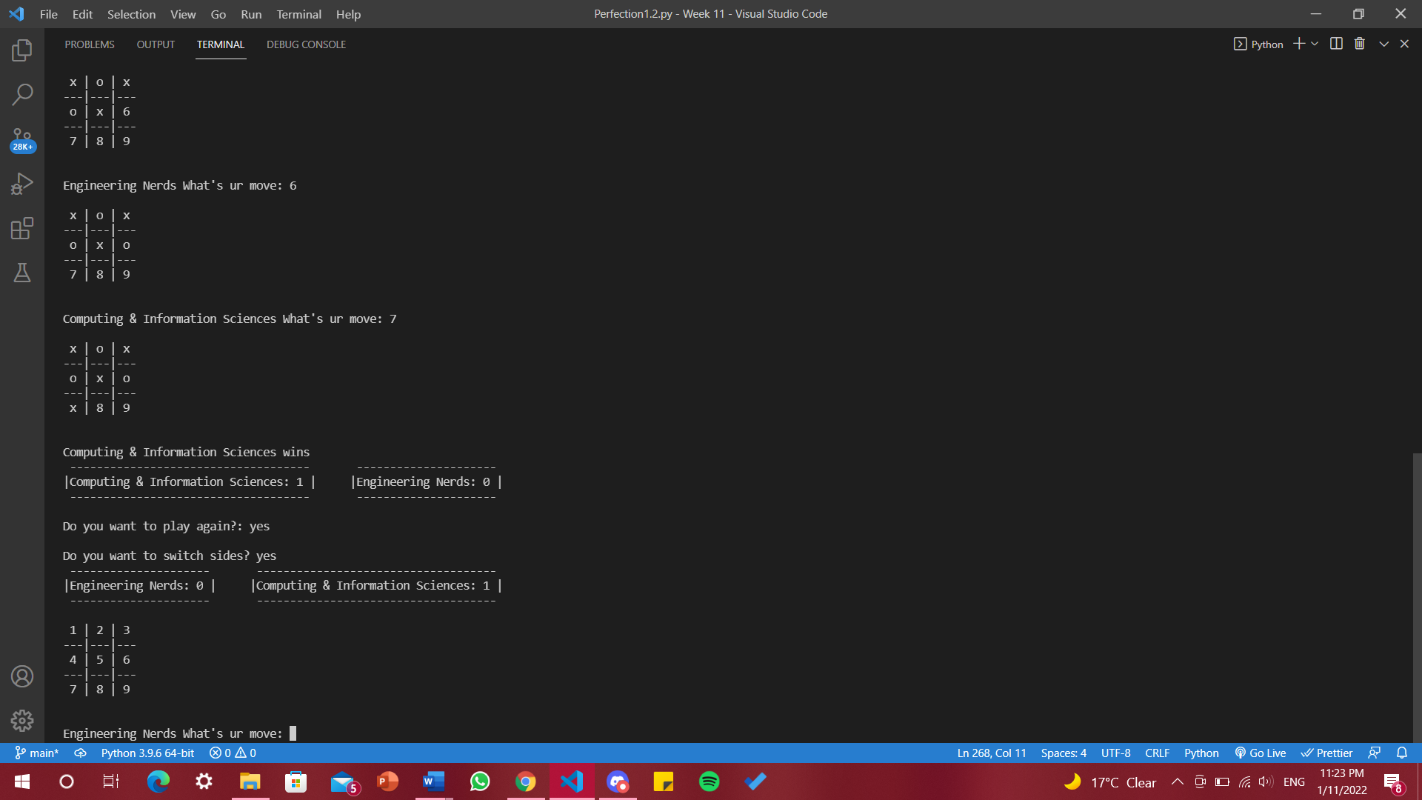

This is the final output of our game!

# **References**

[1] Gaddis, Tony. *Starting out with Python*. Pearson, 2022.